After typing in node bamazonCustomer.js, user will see a list of the items available.

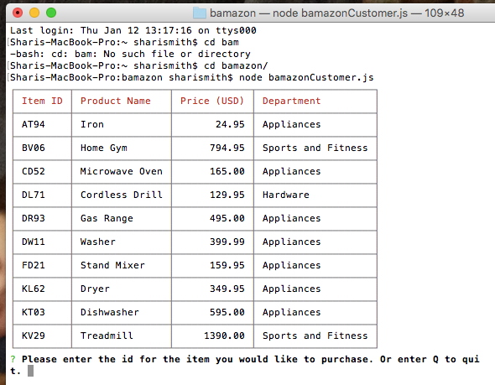

The user is then be prompted to enter the id of the item they would like to purchase and what quantity.

Once the user enters the item and qunatity, a list will come up showing what they purchased and the total cost.

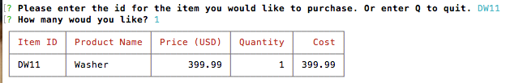

The user will be shown an updated list of the items available and asked again to enter the id for any items they want to purchase.

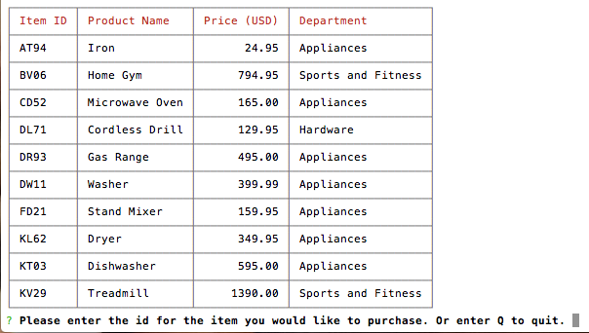

Upon entering “Q” for quit, the user is shown their total purchase amount for this shopping trip.

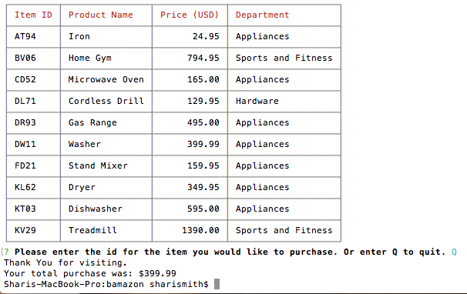

![First Screen Shot](https://github.com/Cherrybug68/bamazon/images/First_Screen_Shot.png)